Excel Assignment – 6

1. What are the various elements of the Excel interface? Describe how they’re used.

**Cells**

Cells are the rectangular boxes located in the central area of a worksheet. Cells contain labels, data, and formulas. To make worksheet data stand out, cells can be formatted to change the text or to add a fill color. Cells may also contain charts and images that explain the cell data.

Each cell holds only one piece of data at a time. The cell in the worksheet is identified by a cell reference, which is a combination of letters and numbers such as A1, F456 or AA34.

**Column Letters**

Columns run vertically on a worksheet and each one is identified by a letter in the column header such as A, B, C and D.

**Formula Bar**

The Formula Bar is located above the worksheet and displays the contents of the active cell. The Formula Bar is also used to enter or edit data and formulas.

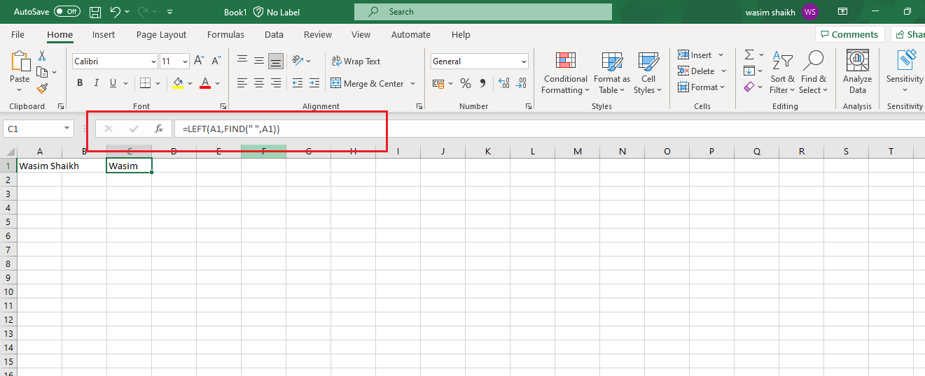

**Name Box**

The Name Box is located to the left of the Formula Bar. The Name Box displays the cell reference or the name of the active cell. In the above image cell G2 is the active cell.

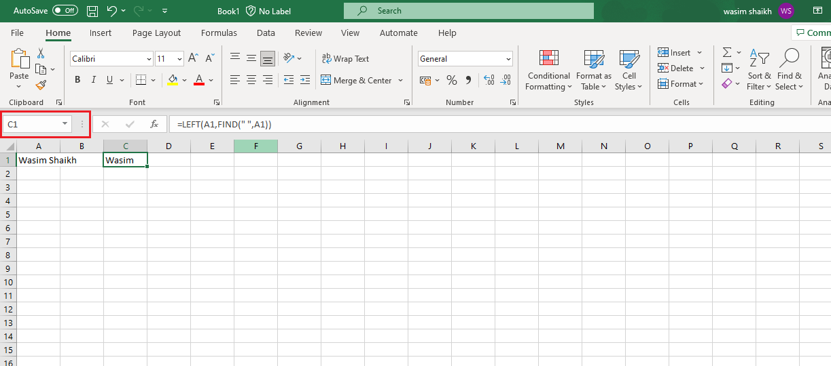

**Quick Access Toolbar**

The Quick Access Toolbar adds frequently used commands to the top of the Excel screen. Make your work go faster by adding commands to the Quick Access Toolbar instead of searching through the tabs to find what you need. To find these frequently used commands, select the Customize

Quick Access Toolbar down arrow.

**Ribbon Tabs**

Ribbon tabs are part of the horizontal ribbon menu that contains links to various features of the program. Each tab – such as Home, Page Layout, and Formulas – contains a number of related features and options that are activated by clicking on the appropriate icon.

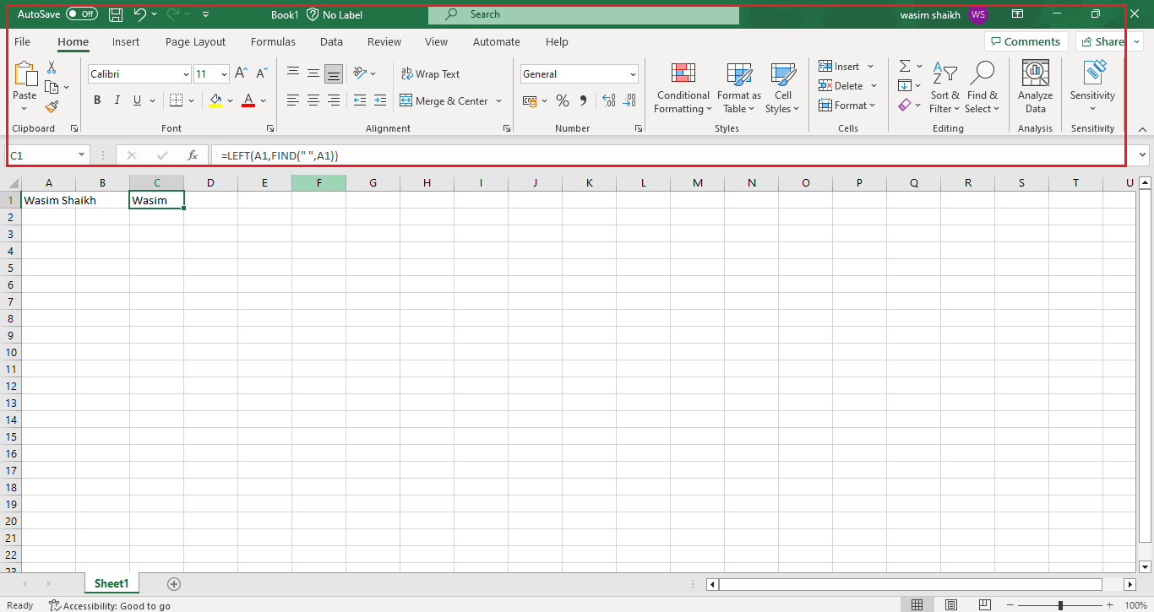

**File Tab**

The File tab was introduced in Excel 2010, replacing the Excel 2007 Office Button, and it works differently than the others tabs. Instead of displaying options on the horizontal ribbon, the File tab opens a different screen.

**Row Numbers**

Rows run horizontally in a worksheet and are identified by a number in the row header.

**Sheet Tabs**

A new Excel workbooks opens with a single worksheet, but workbooks can contain multiple worksheets. Each worksheet has its own tab at the bottom of the screen. The Sheet tab displays the name of the worksheet, such as Sheet1 or Sheet2.

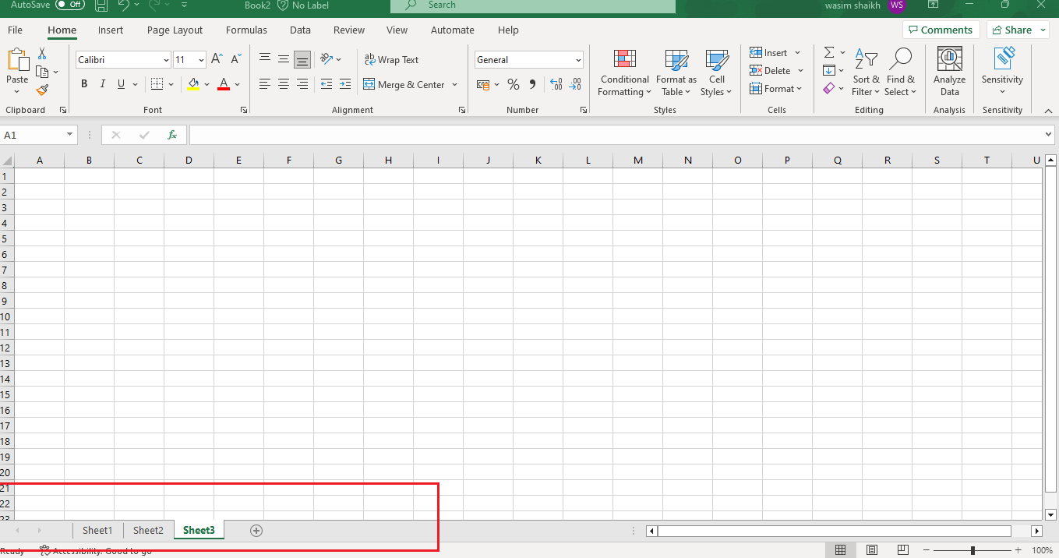

**Status Bar**

The Status Bar, which runs horizontally along the bottom of the screen, can be customized to display a number of options, most of which display information about the current worksheet, data the worksheet contains, and the keyboard. The keyboard information includes whether the Caps Lock, Scroll Lock, and Num Lock keys are turned on or off.

**Zoom Slider**

Located in the bottom right corner of the Excel screen, the Zoom slider changes the magnification of a worksheet when you drag the slider box back and forth, or select Zoom Out or Zoom In located at either end of the slider.

1. Write down the various applications of Excel in the industry.

i) Calculating

ii) Accounting

iii) Charting

iv) Inventory Tracking

v) Calendars and Schedules

vi) Seating charts

vii) Goal planning worksheet

viii) Mock-ups

ix) Task list

x) Checklist

xi) Project Management Charts

xii) Time Logs

1. On the ribbon, make a new tab. Add some different groups, insert commands in the groups and name them according to their commands added. Copy and paste the screenshot of the steps you followed.

First go to File click on Options and then click on Customize Ribbon and add new tab and rename it as Formatting.

Click on New Group and rename it as Border and Format (Custom) and this will create a new tab.

1. Make a list of different shortcut keys that are only connected to formatting with their functions.

|  |  |
| --- | --- |
| To do this | Press |
| Close a workbook. | Ctrl+W |
| Open a workbook. | Ctrl+O |
| Go to the **Home** tab. | Alt+H |
| Save a workbook. | Ctrl+S |
| Copy selection. | Ctrl+C |
| Paste selection. | Ctrl+V |
| Undo recent action. | Ctrl+Z |
| Remove cell contents. | Delete |
| Choose a fill color. | Alt+H, H |
| Cut selection. | Ctrl+X |
| Go to the **Insert** tab. | Alt+N |
| Apply bold formatting. | Ctrl+B |
| Center align cell contents. | Alt+H, A, C |
| Go to the **Page Layout**tab. | Alt+P |
| Go to the **Data** tab. | Alt+A |
| Go to the **View** tab. | Alt+W |
| Open the context menu. | Shift+F10 or |
| Windows Menu key |
| Add borders. | Alt+H, B |
| Delete column. | Alt+H, D, C |
| Go to the **Formula** tab. | Alt+M |
| Hide the selected rows. | Ctrl+9 |
| Hide the selected columns. | Ctrl+0 |

1. What distinguishes Excel from other analytical tools?

The Microsoft Excel is easy to use and you can learn from lot of free resources also you can do lot of things with excel modelling, visualization, reports, dynamic charts, etc. It can help you understand the meaning of many operations before further learning other tools (such as Python and R).

1. Create a table and add a custom header and footer to your table.

On the “Page Layout” tab, in the bottom-right corner of the “Page Setup” section, click the arrow icon.

On the “Page Setup” dialog box, click the “Header/Footer” tab.

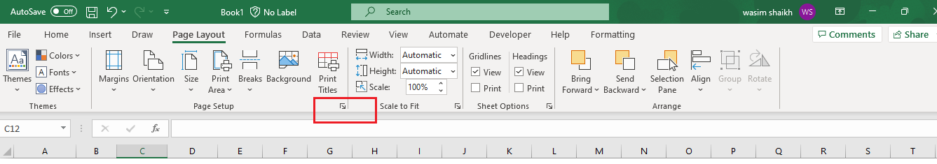

To specify the header click on Custom Header and footer click on Custom Footer.

